Technical Report

**Electrical**

Firstly, the circuit diagram…

Sensors:

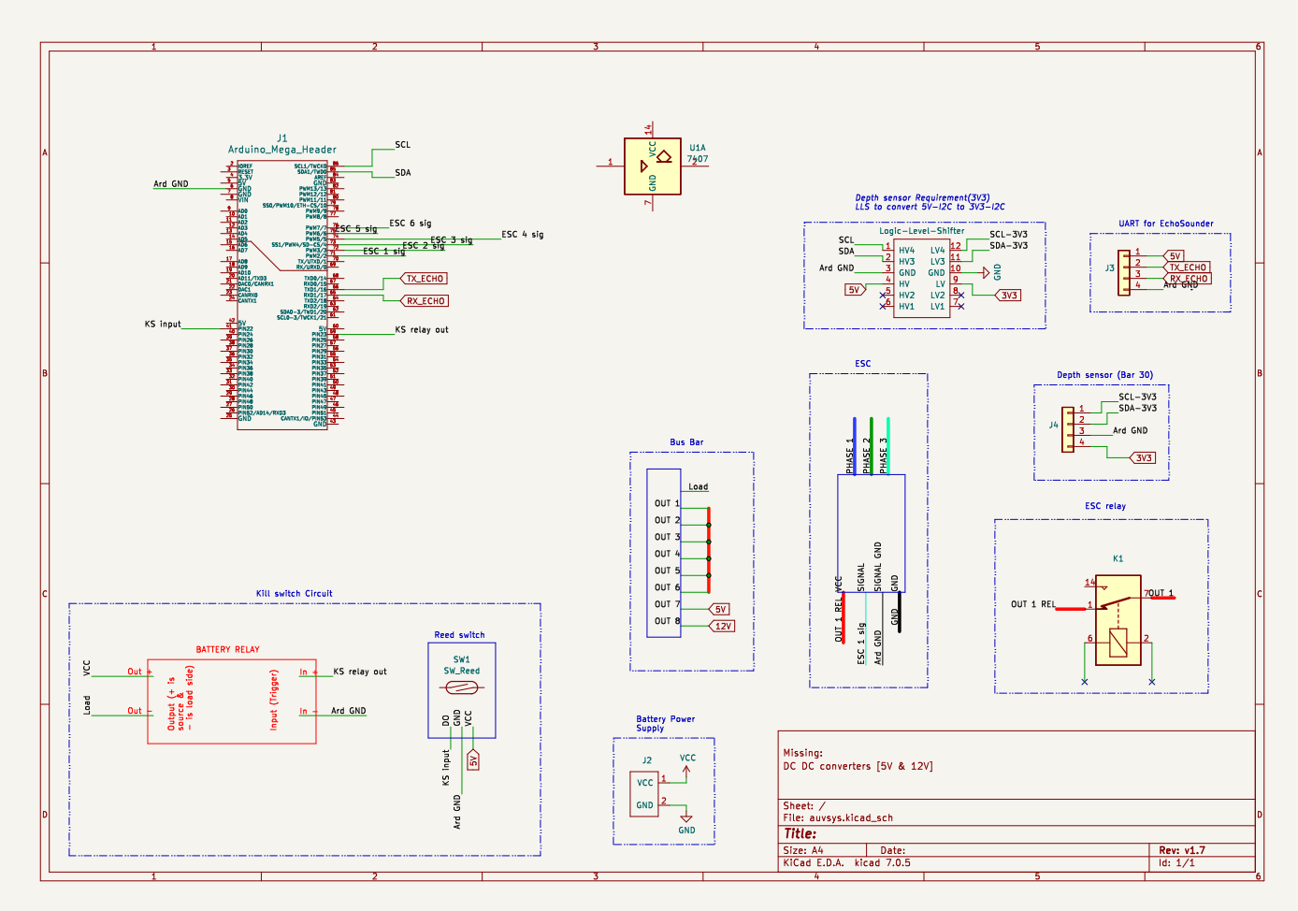

Kill switch:

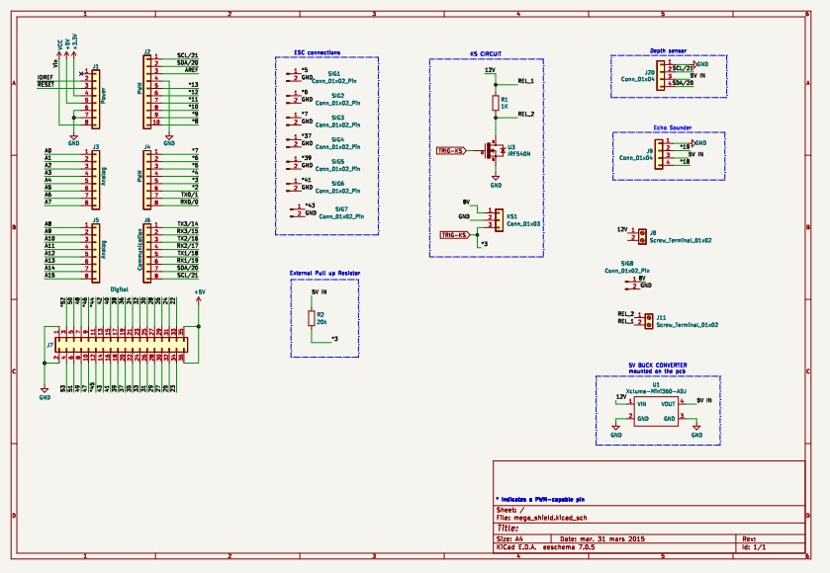

**Depth sensor:**

Here, from practical experience we found that we did not need the i2c converter, you can connect the depth sensor power directly to the 5V supply from Arduino and GND.

There is also a method to increase the precision of the depth sensor to .1cm although I personally am not sure how to do it. (reach Reuben Mathew for that).

**Echo sounder:**

There is a code to manual change between air and water and other such details, personally, I didn’t find the air values to be any accurate at all. The echo sounder works better the farther away it is from the surface of the water.

Refer the pinger code uploaded on OneDrive.

**Kill switch:**

My suggestion for the kill switch is to use a normal push kill switch or a the kill switch sold by blue robotics. While the advantages of blue robotics kill switch is clear. With a normal kill switch you could use a pull-up/pull-down resistor which I believe will be more stable than current reed sensor kill switch. There is a suspicion that the biggest reason for the unreliability is that the kill switch (with green light) is much older than the new one (red light). Although the new kill switch has to be tested further.

**Wiring:**

I believe the Achilles heel of the entire wiring system is the bakelite connectors. The bakelite connectors must be tightened on a regular basis to avoid loose connection. Moreover, they take up a lot of space. The reason I chose bakelite connectors is because the ESCs use forked connectors, but if you are careful, you can desolder the ESCs and solder normal 14 AWG (or 12AWG, not sure) wires on the ESCs and choose any connector type you want. 14AWG silicone multi strand wires are what I found to be the most convenient. Note mostly in raniganj no one use AWG and you must convert it to mm^2 when asking outside and specifically ask for silicon wires to get the ones which we used.

**Signal Pins:**

The Signal pins can be connected to any of the digital pins or the pwm pins on the Arduino to generate pwm signals. All the ground wires from the ESCs have a common ground on the Arduino. Although since we use a single battery the ground is common throughout the auv. While I used a perfboard to make connections as we go along, finalising the design and fabricating a pcb will be more effective, in terms of space and having tight connections.

**Kill switch circuit:**

The circuit made for the old hull stopped working after a while. We had a lot of problems at the beginning as well to make it work. We never figured out what the actual problem might be about it. The perfboard for the new hull is working without any issues consistently.

**Relays:**

We have been using T91 relays as these have the appropriate current and voltage rating for us to use, I have used connectors on top of the relay rather than the pins at the bottom, this makes the connections tight but this means a need for another perfboard/pcb for the relays only. But there are ways to add them to the pcb, this depends on the changes made to the internal mountings.